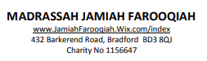
Time | Mon | Tues | Wed | Thurs | Fri
1 hour | Quran  Nazra | Quran  Nazra | Quran  Nazra | Quran  Nazra | Quran  Nazra
15 mins | Tajweed  Going basic pronunciation of each letter | Imaan Mufasal/mujmal | Tajweed  Going basic pronunciation of each letter | Daily Duas | Daily Sunnah
10 mins | Recital of salah | Recital of salah | Recital of salah | Recital of salah | Recital of salah

